Data for non-linear (polynomial model):
x | 1 | 3 | 4 | 5 | 6 | 7 | 8 | 9 | 10
y | 2 | 7 | 8 | 10 | 11 | 11 | 10 | 9 | 8

Output:
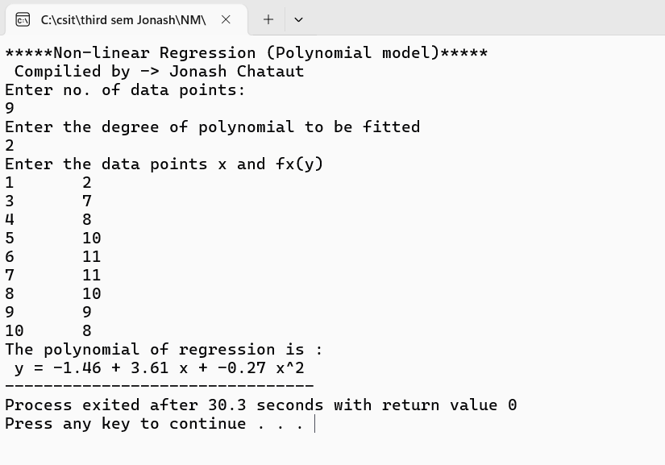

Data for non-linear (exponential model):
x | 0 | 1 | 3 | 5 | 7 | 9
y | 1 | 0.891 | 0.708 | 0.562 | 0.447 | 0.355

Output:
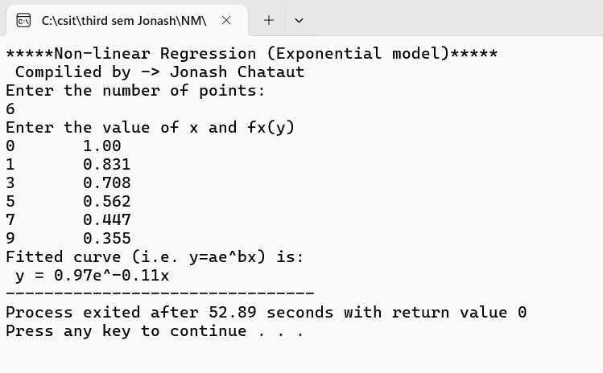

Data for Linear Regresson:
x | 1 | 2 | 3 | 4 | 5
y | 3 | 5 | 7 | 10 | 12

Output:
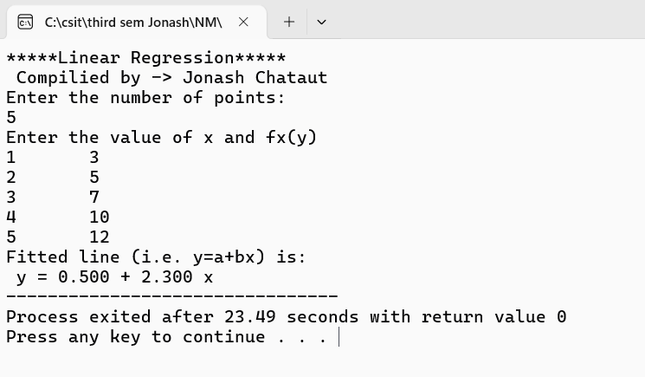

Data for Newton’s forward difference interpolation:
x | 1 | 1.3 | 1.6 | 1.9 | 2.2
F(x) | 0.765198 | 0.620086 | 0.455402 | 0.281819 | 0.110362

Output:
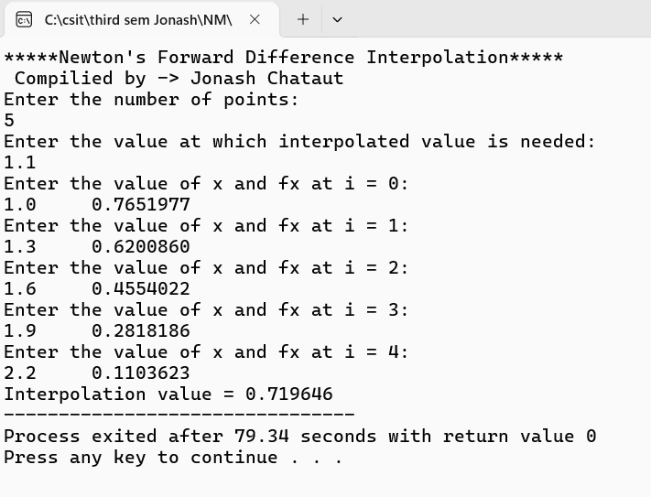

Data for Newton’s divided difference interpolation:
x | 3 | 7 | 9 | 10
F(x) | 168 | 120 | 72 | 63

Output:
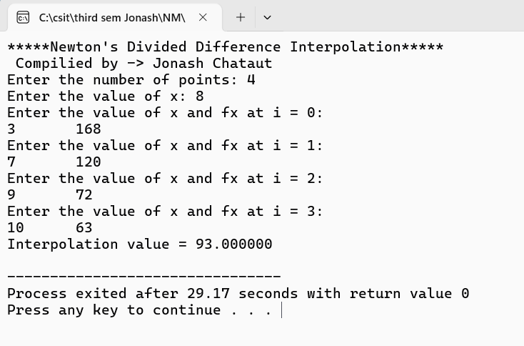

Data for Lagrange interpolation:
x | 0 | 10 | 15 | 20 | 22.5 | 30
F(x) | 0 | 227.04 | 362.78 | 517.35 | 602.97 | 901.67

Output:
